Table of Contents

Chapter - 01 2

1.1. Introduction: 2

1.4. Twitter API Data ingestion: 5

1.5. Time Series Analysis with Twitter Data: 6

CHAPTER – 03 9

2.1. Model Learning and Prediction: 9

Conclusion: 15

References 17

# **Chapter - 01**

# **Introduction:**

The Twitter platform has emerged as one of the most important social media analytics platforms, where users can share their thoughts and opinions on various topics by writing short messages called tweets. These tweets can be analyzed to gain insights into public sentiment towards a particular brand, product, event, or any other topic of interest. The goal of sentiment analysis on Twitter is to determine whether a tweet expresses a positive, negative, or neutral sentiment towards a particular topic. This can be done by analyzing the text of the tweet itself, as well as other factors such as the author's location, time of day, and the use of certain keywords or hashtags. Sentiment analysis on Twitter can be used for a variety of purposes, such as brand reputation management, social media marketing, and public opinion polling.

To perform sentiment analysis on Twitter, NLP techniques such as tokenization, part-of-speech tagging, and named entity recognition can be used to extract relevant information from tweets. Machine learning algorithms such as logistic regression, support vector machines, and neural networks can then be trained on labeled datasets to classify tweets into positive, negative, or neutral categories. Sentiment analysis on Twitter is a challenging task, as tweets are often short, informal, and full of noise such as sarcasm and irony, which can be difficult to detect using traditional NLP techniques.

While there has been a fair amount of research on how sentiments are expressed in genres such as online reviews and news articles, how sentiments are expressed given the informal language and message length constraints of microblogging has been much less studied. Features such as automatic part of speech tags and resources such as sentiment lexicons have proved useful for sentiment analysis in other domains. Tweet sentiment polarity classifications are one of the most critical elements of emerging real-time analytics applications in the information value chain. Consequently, a number of commercial and free Twitter sentiment classification tools have been created. Over 50 tools are estimated to be available, and new start-up companies and academic offerings emerge each month. The effectiveness of the multitude of tools currently available remains unclear.

**1**

It is important to conduct extensive benchmarking for the following reasons:

* The goal is to provide potential users with a "consumer report" on existing sentiment analysis tools on Twitter.
* For the purpose of assessing the current state of Twitter sentiment analysis and to examine possible enhancements.

Several Frameworks have been developed in recent years for analyzing sentiments in informal social media text.

Here are some common frameworks that can be used for analyzing sentiment on Twitter:

* 1. **Machine learning frameworks:**

In a machine learning framework, sentiment analysis is performed using a machine learning algorithm that is trained on a labeled dataset of tweets. The algorithm learns to classify tweets into positive, negative, or neutral categories based on patterns in the tweet text and other features such as user metadata and tweet content. Machine learning frameworks can be very accurate but require extensive training data and may be computationally expensive.

**Lexicon-based frameworks:**

In a lexicon-based framework, sentiment analysis is performed using a pre-built sentiment lexicon, which contains a list of words and their associated sentiment scores. The sentiment score of a tweet is determined by summing the sentiment scores of the words in the tweet. Lexicon-based frameworks can be very accurate and can account for nuances such as sarcasm and negation, but may require extensive pre-processing of the tweet text.

**Rule-based frameworks:**

In a rule-based framework, sentiment analysis is performed based on a set of predefined rules or heuristics. For example, a rule-based framework may assign a positive sentiment score to tweets that contain words such as "love" or "amazing," and a negative sentiment score to tweets that contain words such as "hate" or "disappointing." Rule-based frameworks are relatively simple to implement but may not be as accurate as other approaches.

**Hybrid frameworks:**

A hybrid framework combines two or more of the above frameworks to improve the accuracy of sentiment analysis. For example, a hybrid framework may use a lexicon-based approach to capture the sentiment of individual words in a tweet, and then use a machine learning algorithm to classify the overall sentiment of the tweet based on the sentiment scores of its constituent words.

**2**

The choice of framework will depend on the specific needs and resources of the analysis, as well as the complexity and nuances of the data being analyzed.

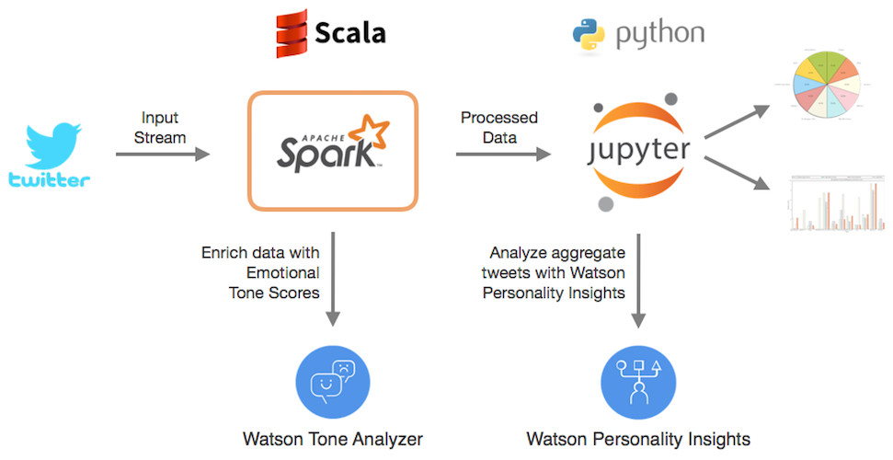

Streaming data analysis is the process of analyzing data as it is generated and continuously flowing in real-time. In order to analyze data streams in real-time, an architecture is required that can handle the volume, velocity, and variety of data being generated.

* 1. **Key Components:**

1. **Data Sources**

The first component of a streaming data analysis architecture is the data sources. Data can be generated from a wide variety of sources such as social media, sensors, web logs, mobile devices, and more. The data sources need to be able to stream data in real-time so that the analysis can be performed on the fly.

1. **Data Processing**

The third component of a streaming data analysis architecture is the data processing layer. This layer is responsible for processing the ingested data in real-time and extracting insights from it. This layer can be implemented using various tools and frameworks such as Apache Spark Streaming, Apache Flink, or Apache Storm. These frameworks can process data streams in real-time and perform operations such as filtering, aggregating, joining, and more.

**3**

1. **Data Ingestion**

The second component of a streaming data analysis architecture is the data ingestion layer. This layer is responsible for capturing and storing the data streams in a way that is scalable and fault-tolerant. Technologies such as Apache Kafka, Apache Flume, or Apache Nifi can be used to ingest data from the sources and store them in a distributed, fault-tolerant data store such as Apache Hadoop HDFS or Apache Cassandra.

1. **Analytics and Visualization**

The fourth component of a streaming data analysis architecture is the analytics and visualization layer. This layer is responsible for providing insights and visualization of the data being processed in real-time. Technologies such as Kibana, Tableau, or Apache Zeppelin can be used to visualize the insights and provide real-time dashboards for monitoring the data streams.

1. **Storage**

The fifth component of a streaming data analysis architecture is the storage layer. This layer is responsible for storing the results of the data processing layer for future analysis and reporting. Technologies such as Apache Hadoop HDFS, Apache Cassandra, or Amazon S3 can be used to store the processed data in a scalable, fault-tolerant way.

# **Twitter API Data ingestion:**

Twitter provides APIs that allow developers to access the Twitter platform and retrieve data in real-time. A process of extracting real-time data from Twitter using the Twitter API and storing it in a distributed, fault-tolerant data store for real-time streaming data analysis. Twitter provides developers with APIs that allow them to access the Twitter platform and retrieve data in real-time. The first step in Twitter API data ingestion is to create a Twitter Developer account and a Twitter App. This will provide the necessary credentials to access the Twitter API. Next, the Streaming API is chosen for retrieving a continuous stream of real-time data from Twitter. The API is configured based on the type of data required, such as filtering the stream based on keywords, hashtags, users, locations, and more.

**4**

Once the API is configured, a Twitter API client library such as Tweepy or Twitter Streaming API can be used to connect to the API and retrieve the data streams. The data streams can then be stored in a distributed, fault-tolerant data store such as Apache Kafka, Apache Flume, or Apache Nifi. The data store can then be used to process the data in real-time using tools such as Apache Spark Streaming, Apache Flink, or Apache Storm.

The ingested data can be used for real-time streaming data analysis to extract insights and perform operations such as filtering, aggregating, joining, and more. The insights can be visualized and monitored in real-time using technologies such as Kibana, Tableau, or Apache Zeppelin.

It is important to note that Twitter API has certain restrictions and rules regarding data usage and distribution, so it is important to comply with their policies and guidelines. Additionally, appropriate security measures should be taken to protect the ingested data and ensure data privacy.

# **Time Series Analysis with Twitter Data:**

Twitter data, being time-stamped, can be used for time series analysis to extract valuable insights and trends over time. Time series analysis with Twitter data is a powerful technique for extracting insights and trends over time. It can be used for a wide range of applications such as sentiment analysis, predicting user behavior, and monitoring trends in real-time. The first step in time series analysis is to collect the relevant Twitter data. This can be done using the Twitter API or through third-party data providers. Depending on the research question, the data can be filtered by time range, location, or specific keywords. Once the data is collected, it needs to be cleaned to remove irrelevant information and ensure data consistency. This includes removing duplicates, retweets, and spam tweets. The data can also be normalized, for example, by converting text to lowercase and removing stop words.

After cleaning, the data is prepared for time series analysis. This involves selecting a time interval for analysis (e.g., hourly, daily, weekly) and aggregating the data accordingly. The data can be aggregated using various methods such as count, sum, mean, or median. Once the data is prepared, it can be visualized using time series plots. Time series plots show the trends and patterns of the data over time. These plots can be used to identify seasonality, trends, and anomalies in the data. After visualizing the data, time series modeling can be used to analyze the data further. Time series modeling involves fitting a mathematical model to the data to predict future trends and patterns. Common time series models include ARIMA (autoregressive integrated moving average), SARIMA (seasonal ARIMA), and Prophet. The final step in time series analysis is to interpret the results and draw conclusions. This involves analyzing the time series plots and the results of the time series models. The insights gained from time series analysis can be used for forecasting, anomaly detection, or identifying patterns and trends over time.

**5**

**6**

**CHAPTER - 02**

**2.1. Literature View**

Twitter sentiment analysis has been a popular topic in the field of natural language processing (NLP) and machine learning. Numerous studies have been conducted on this topic, and they can be broadly categorized into three areas: data collection and preprocessing, feature extraction, and classification techniques.

In terms of data collection and preprocessing, many studies have focused on developing methods to efficiently collect tweets and preprocess them to remove noise and irrelevant information. Some studies have used techniques such as user profiling, topic modeling, and keyword extraction to identify relevant tweets and remove noise.

In terms of feature extraction, studies have focused on developing methods to identify and extract features from tweets that can be used to classify the sentiment of the tweet. Some common features that have been used include word frequency, part-of-speech tags, sentiment lexicons, and emoticons. [5]

Finally, in terms of classification techniques, studies have focused on developing machine learning algorithms that can accurately classify the sentiment of a tweet. Some popular techniques include Naive Bayes, Support Vector Machines, and Random Forest. [2]

Overall, the literature on Twitter sentiment analysis suggests that it is a challenging task due to the noisy nature of the data and the need for accurate feature extraction and classification techniques. However, with the increasing use of social media, sentiment analysis on platforms like Twitter has become an important tool for businesses, governments, and individuals to understand public opinion and sentiment. [4]

**7**

# **CHAPTER – 03**

# **2.1. Model Learning and Prediction:**

Model learning and prediction are essential steps in machine learning and data analysis. These steps involve training a model on a given dataset and using the trained model to make predictions on new, unseen data. Collect relevant Twitter data using the Twitter API or third-party data providers. The data can be filtered by time range, location, or specific keywords. Once the data is collected, it needs to be cleaned to remove irrelevant information and ensure data consistency. This includes removing duplicates, retweets, and spam tweets. The data can also be normalized, for example, by converting text to lowercase and removing stop words.

After cleaning, the data is preprocessed to extract relevant features for model learning. This includes extracting features such as tweet text, hashtags, user mentions, and more. Text-based features can be processed further using techniques such as tokenization, stemming, and feature scaling. After the features are extracted, a suitable model is selected for learning and prediction. The choice of the model depends on the research question, the type of data, and the level of accuracy required. Popular models for Twitter data analysis include decision trees, random forests, and neural networks. After selecting a suitable model, the data is split into a training set and a testing set. The training set is used to train the model by adjusting the model parameters to fit the training data.

The testing set is used to evaluate the performance of the trained model. Once the model is trained, it is validated using cross-validation or other techniques to ensure that it is not overfitting or underfitting the data. Cross-validation involves splitting the data into multiple folds and using each fold for training and testing. After validation, the trained model is used to make predictions on new, unseen data. This involves feeding the new data into the trained model and using it to make predictions. The predictions can be used for a wide range of applications such as sentiment analysis, topic modeling, and user behavior analysis. Finally, the performance of the model is evaluated using metrics such as accuracy, precision, recall, and F1 score. The results are used to improve the model and fine-tune the model parameters for better performance.

The preprocessing steps for data visualization in Python can vary depending on the type of data and the specific visualization technique being used. The preprocessing steps for visualizing Twitter sentiment analysis data in Python. First of all Import the Twitter sentiment analysis data into Python using a library such as Pandas or NumPy. Before visualizing the data, it may be necessary to clean and prepare the data for analysis. Clean the data to remove any unnecessary characters, such as URLs, mentions, hashtags, or emojis. This can be done using regular expressions or string methods. Once the data is clean, the appropriate visualization technique that best represents your data. Preprocess the text data by tokenizing, stemming, lemmatizing, and removing stop words. This can be done using libraries such as NLTK or spaCy. When visualization technique done, we create the visualization by specifying the data to be visualized and any relevant parameters, such as user_name, user_id, user_location, user_followers, user_friends, user_favourites, user_verified, hashtags, source, is_retweet.

**8**

Features refer to the attributes or characteristics of a tweet that are used to determine its sentiment. These features are extracted from the text of the tweet and can be both linguistic and non-linguistic. Plot the sentiment of the Twitter data over time using a line chart. This can be done using the Matplotlib or Seaborn library in Python. Visualize the sentiment of the Twitter data by topic or keyword using a bar chart. Plot the sentiment of the Twitter data by location using a heatmap or a choropleth map. This can be done by geocoding the tweets and aggregating the sentiment scores by location. Add interactivity to the visualizations by enabling the user to filter the data by date, location, or topic.[3]

**9**

**CHAPTER – 04**

**4.1. Results:**

**Visualization Of Two Data Sets:**

World Wide & with Specific Country.

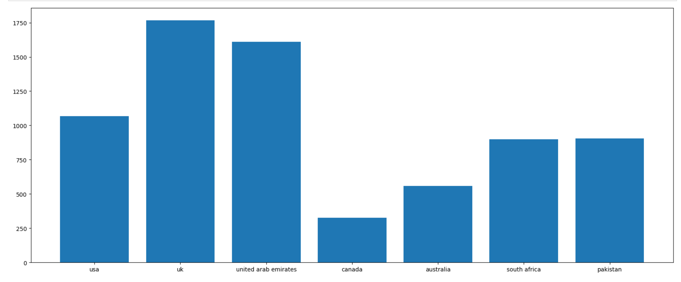

Figure 1 - World Wide Data Visualization

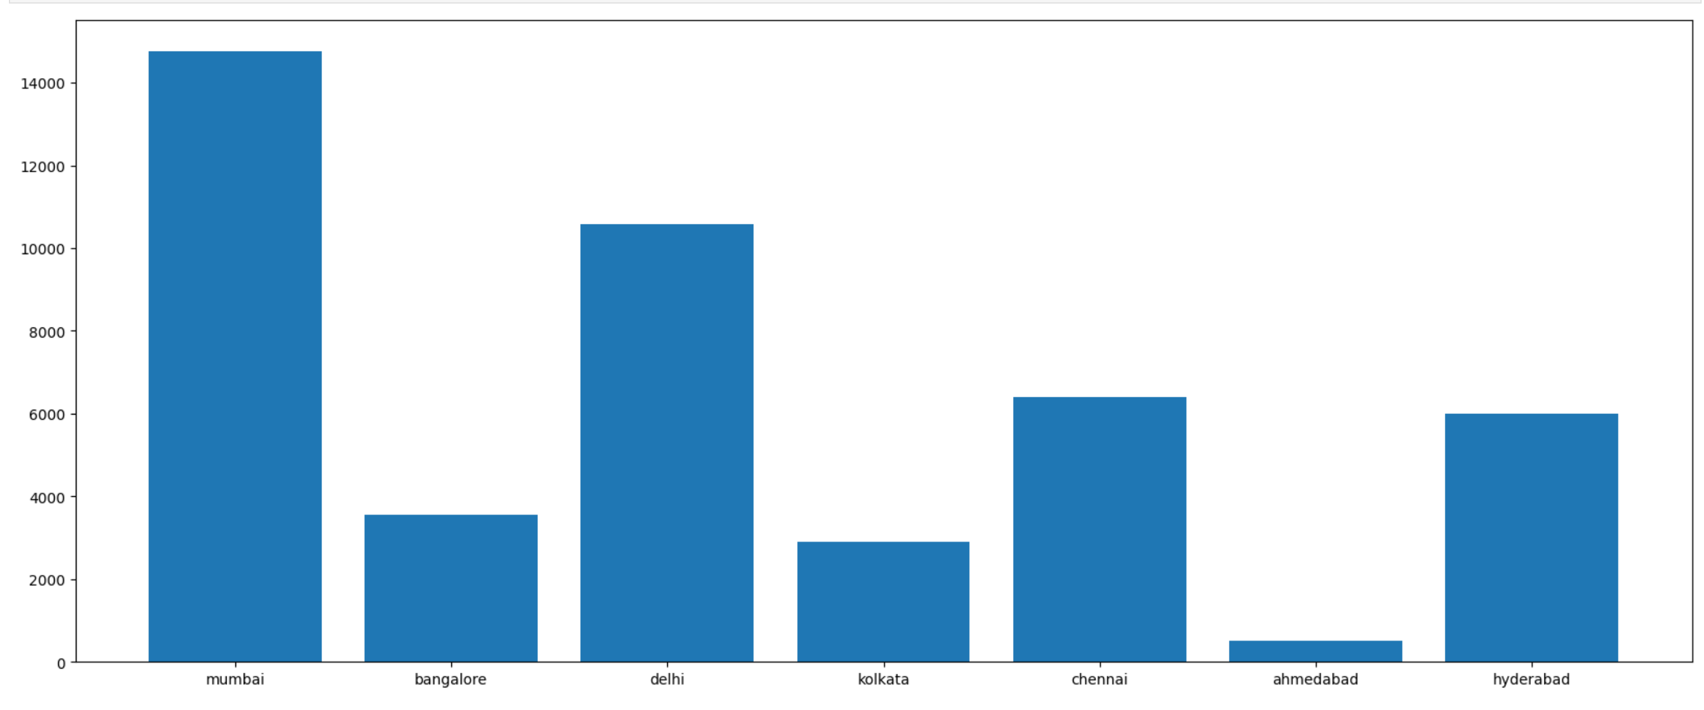

Figure 2 - Country Wise Data Visualization

**10**

We can customize it by adjusting various parameters, such as the axis labels, tick marks, and legends. Finally, we save the visualization as an image or an interactive HTML file, depending on needs.

**Here are some Graphical Representations:**

**4.2. Change Sentiments:**

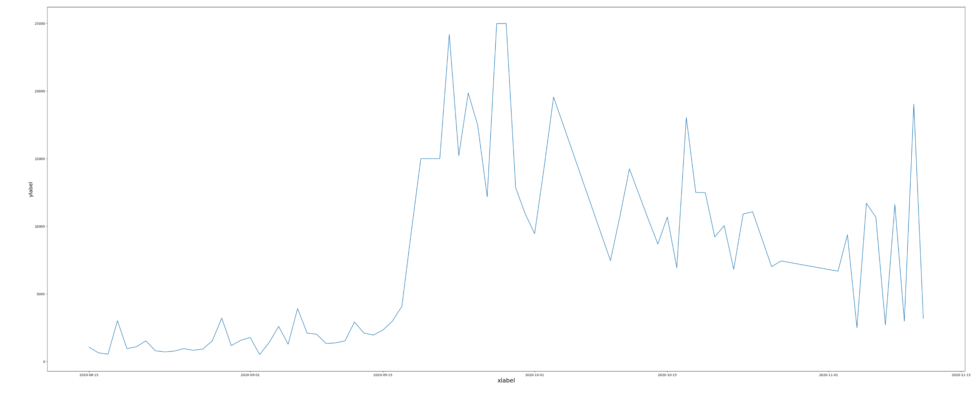

Figure 3 - Change Sentiments on Months

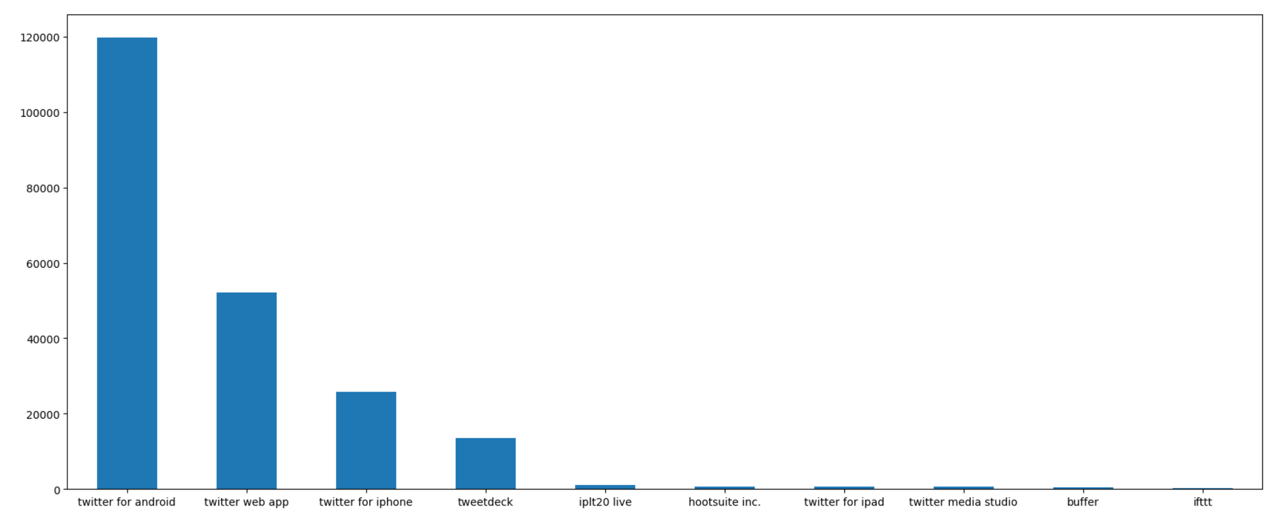

Figure 4 - Twitter Source

**11**

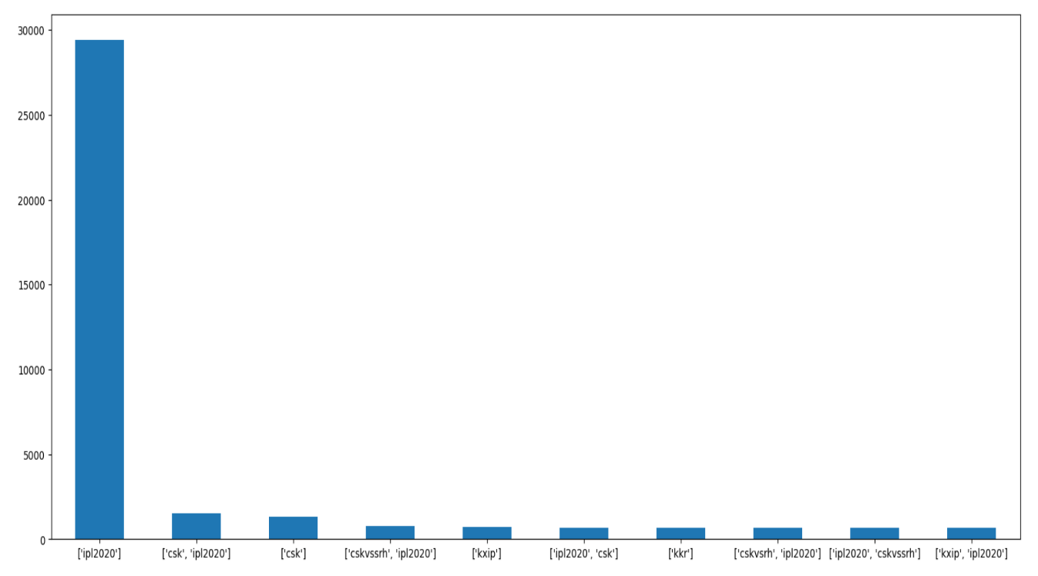

Figure 5 - Hashtags

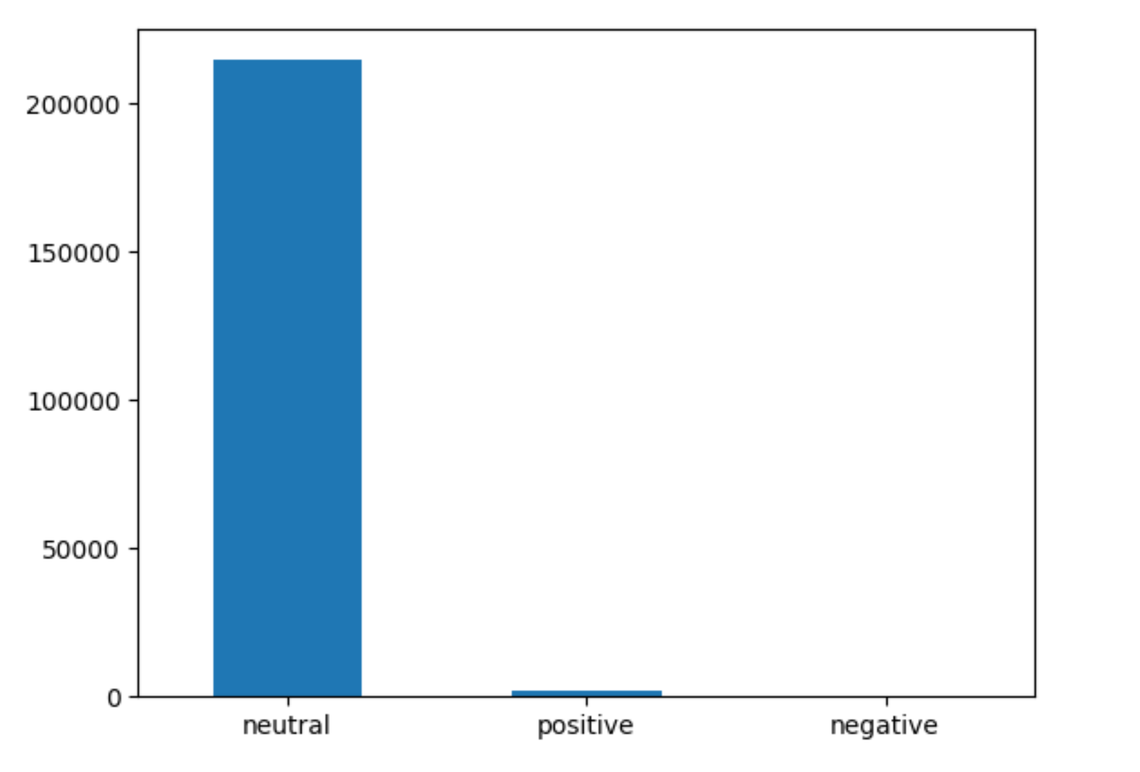

**12**

Figure 6 - Sentiment Analysis

Performance and accuracy are critical metrics in evaluating the effectiveness of a Twitter sentiment analysis system. Performance refers to the speed and efficiency of the system, while accuracy refers to the correctness of the predictions made by the system. There are several ways to measure the performance and accuracy of a Twitter sentiment analysis system. Precision measures the proportion of true positive predictions made by the system, while recall measures the proportion of actual positive cases that were correctly identified by the system. A high precision and recall score indicate that the system is making accurate predictions. The F1 score is the harmonic mean of precision and recall, and it provides a balanced measure of the system's accuracy. The F1 score ranges from 0 to 1, with a score of 1 indicating perfect accuracy. A confusion matrix is a table that summarizes the true positive, false positive, true negative, and false negative predictions made by the system. The Receiver Operating Characteristic (ROC) curve is a plot that shows the trade-off between the true positive rate and false positive rate of the system at different threshold values.

The performance and accuracy of a Twitter sentiment analysis system can be improved by using more advanced machine learning algorithms, such as neural networks and deep learning, and by using more sophisticated feature selection techniques, such as feature engineering and feature extraction. Additionally, the system can be trained and evaluated using larger and more diverse datasets to improve its accuracy and robustness.

**13**

|  |  |  |  |  |
| --- | --- | --- | --- | --- |
|  | **Precision** | **Recall** | **F1 Score** | **Support** |
| **Negative** | 0.00 | 0.00 | 0.00 | 0.00 |
| **Neutral** | 1.00 | 0.99 | 0.99 | 43380 |
| **Positive** | 0.01 | 0.75 | 0.01 | 4 |
| **Accuracy** |  |  | 0.99 | 43384 |
| **Macro Avg** | 0.34 | 0.58 | 0.34 | 43384 |
| **Weighted Avg** | 1.00 | 0.99 | 0.99 | 43384 |

# **Conclusion:**

Twitter sentiment analysis is a valuable technique for understanding the attitudes, opinions, and emotions expressed in social media data. By applying natural language processing and machine learning techniques to tweets, we can gain insights into the public's reactions to various events, products, and topics. The results of Twitter sentiment analysis can be used for a variety of purposes, such as improving customer satisfaction, assessing brand reputation, measuring public opinion on political issues, and identifying trends and patterns in social media data. However, it is important to note that Twitter sentiment analysis has some limitations, such as the inability to capture the context of a tweet, the use of slang or sarcasm, and the inherent bias in social media data. Therefore, it is crucial to carefully design the sentiment analysis models and validate their accuracy before making any conclusions or decisions based on the results. Twitter sentiment analysis is a useful tool for businesses, governments, and individuals to understand the public sentiment and gain insights into the online conversation on various topics.

Data Visualization is a critical step in analyzing and communicating data effectively. Preprocessing the data before visualization is important to ensure accurate and meaningful insights. In Python, various libraries, such as Matplotlib, Seaborn, Plotly, and Bokeh, are used to create different types of visualizations, such as line charts, bar charts, heatmaps, and choropleth maps. For Twitter sentiment analysis data, additional preprocessing steps, such as cleaning the data, preprocessing the text, and geocoding the tweets, may be necessary before visualization. Adding interactivity to the visualizations can make them more engaging and insightful for the user. Overall, data visualization in Python is a powerful tool for gaining insights and telling a compelling story about the data. Using multiple algorithms on Twitter sentiment analysis can help to increase the accuracy of the predictions. Ensembling the outputs of multiple models can provide a more robust prediction as it reduces the risk of overfitting and leverages the strengths of each algorithm.

Before using multiple algorithms, it is essential to clean and preprocess the data. The data may contain noise, irrelevant or duplicate information. Perform data cleaning techniques such as removal of stop words, punctuation, or URLs to refine the data. Split the data into training and testing sets. The training set is used to train the models, and the testing set is used to evaluate the performance of the models. Choose the algorithms to use for sentiment analysis. Some popular algorithms for sentiment analysis include Naive Bayes, Support Vector Machines (SVM), Random Forest, and Recurrent Neural Networks (RNN).

**14**

Train the chosen algorithms on the training set. Evaluate the performance of each algorithm on the testing set using performance metrics such as accuracy, precision, recall, F1 score, and confusion matrix. Combine the outputs of each algorithm to create an ensemble model. This can be done using various techniques such as majority voting, weighted voting, or stacking. Evaluate the performance of the ensemble model on the testing set using the same performance metrics as before.

**15**

# **References**

1. Bhavsar, Hetu, and Richa Manglani. "Sentiment analysis of Twitter data using Python." *International Research Journal of Engineering and Technology (IRJET)* 6, no. 3 (2019): 510-511.
2. Sarlan, A., Nadam, C., & Basri, S. (2014, November). Twitter sentiment analysis. In *Proceedings of the 6th International conference on Information Technology and Multimedia* (pp. 212-216). IEEE.
3. Pandarachalil, R., Sendhilkumar, S., & Mahalakshmi, G. S. (2015). Twitter sentiment analysis for large-scale data: an unsupervised approach. *Cognitive computation*, *7*(2), 254-262.
4. Kaur, C., & Sharma, A. (2020, October). Social issues sentiment analysis using python. In *2020 5th International Conference on Computing, Communication and Security (ICCCS)* (pp. 1-6). IEEE.
5. Gupta, Bhumika, Monika Negi, Kanika Vishwakarma, Goldi Rawat, Priyanka Badhani, and B. Tech. "Study of Twitter sentiment analysis using machine learning algorithms on Python." *International Journal of Computer Applications* 165, no. 9 (2017): 29-34.
6. Diyasa, I. Gede Susrama Mas, et al. "Twitter sentiment analysis as an evaluation and service base on python textblob." *IOP Conference Series: Materials Science and Engineering*. Vol. 1125. No. 1. IOP Publishing, 2021.
7. Shelar, Amrita, and Ching-Yu Huang. "Sentiment analysis of twitter data." *2018 International Conference on Computational Science and Computational Intelligence (CSCI)*. IEEE, 2018.

**16**